Yara jamal Mahmoud

Lab1/ bash script

Group2

1. Display the lines that contain the word “lp” in /etc/passwd file.

sed -n '/lp/p' /etc/passwd

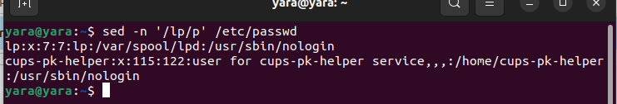

1. Display /etc/passwd file except the third line.

sed '3d' /etc/passwd

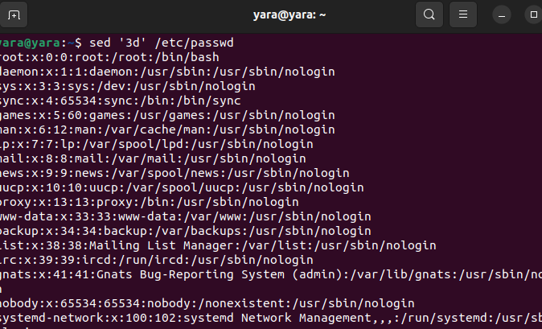

1. Display /etc/passwd file except the last line.

sed '$d' /etc/passwd

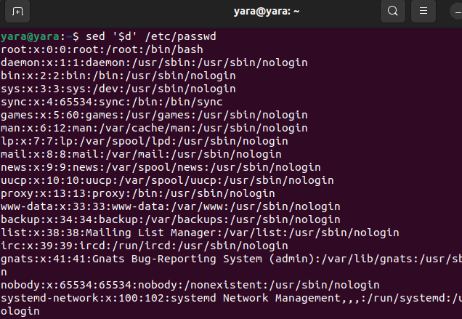

4-Display /etc/passwd file except the lines that contain the word “lp”.

sed '/lp/d' /etc/passwd

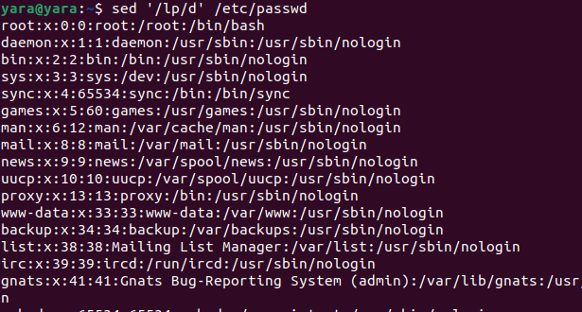

5- Substitute all the words that contain “lp” with “mylp” in /etc/passwd file.

sed -i 's/lp/mylp/g' /etc/passwd

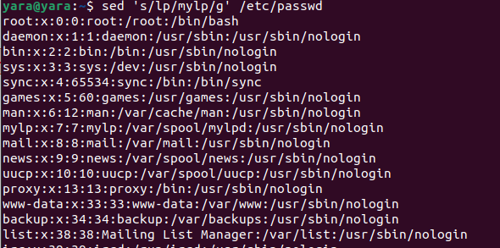

Using awk utility

1. Print full name (comment) of all users in the system.

awk -F':' '{print $5}' /etc/passwd

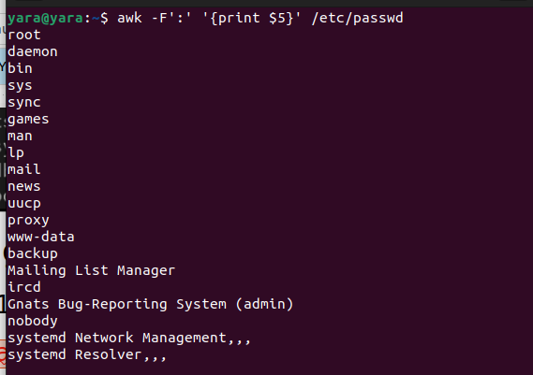

1. Print login, full name (comment) and home directory of all users.( Print each line preceded by a line number)

awk -F':' '{print NR, $1, $5, $6}' /etc/passwd

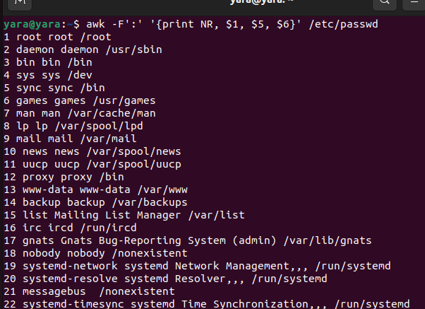

1. Print login, uid and full name (comment) of those uid is greater than 500

awk -F':' '$3 > 500 {print $1, $3, $5}' /etc/passwd

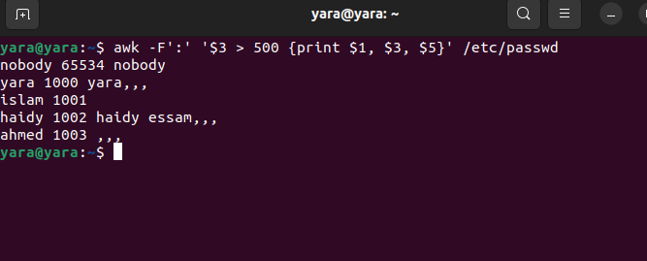

1. Print login, uid and full name (comment) of those uid is exactly 500

awk -F':' '$3 == 500 {print $1, $3, $5}' /etc/passwd

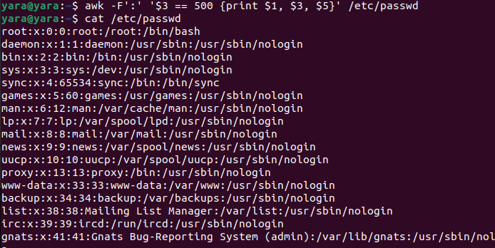

1. Print line from 5 to 15 from /etc/passwd

awk 'NR>=5 && NR<=15' /etc/passwd

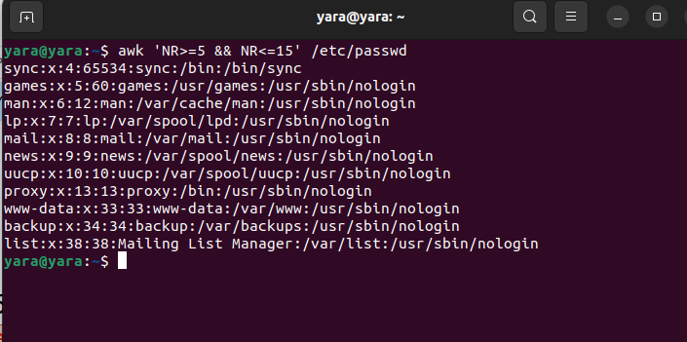

6-Change lp to mylp

awk '{sub(/lp/, "mylp"); print}' /etc/passwd

